**DSC GUI (short) Manual**

**Stage #0 - initialization**

1. Set MATLAB home directory.It'll probably end with "…\Code\DSC".
2. Run "DSCMainGUI.m" (from the directory mentioned above) 🡪 DSC GUI will be opened.
3. Click on "init" , in the upper-left part of the GUI.

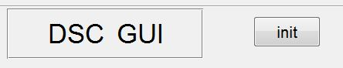

After a few seconds you should see the following message:

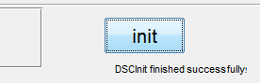

(Also in MATLAB's Command Window)

**Stage #1 – Open the data**

1. Choose the file type you wish to open – (Dicoms or Nii) and click on "Choose data folder". A dialog box will be opened. Enter the directory containing the data files (and only them), mark the first file (either dcm or nii) and press "open". The selected path will be shown in the GUI.
2. Click "Choose output folder" to choose the folder that will contain coreged data files and the maps of the results.
3. Click "Get data – can take some time.

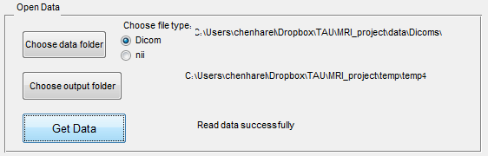

**Stage #2 – Pre-processing**

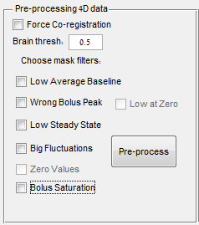

1. You can choose to force Co-registration (even if your data is already coreged). In case the data is new and fresh, Co-registration will be done anyway.
2. Set the threshold for extracting the brain voxels ( a value between 0 and 1). The default should be 0.5.
3. Select which filters to apply for masking the bad voxels:
4. Click Pre-process to begin calculate the mask.

After some time a figure will appear, showing the final mask (in red) for all the slices. Choose to apply filter, or go back to start over.

**Stage #3 – Specifying bolus properties**

After applying the mask (in the previous stage), two windows will be opened: "Time curves" and "bolus properties GUI".

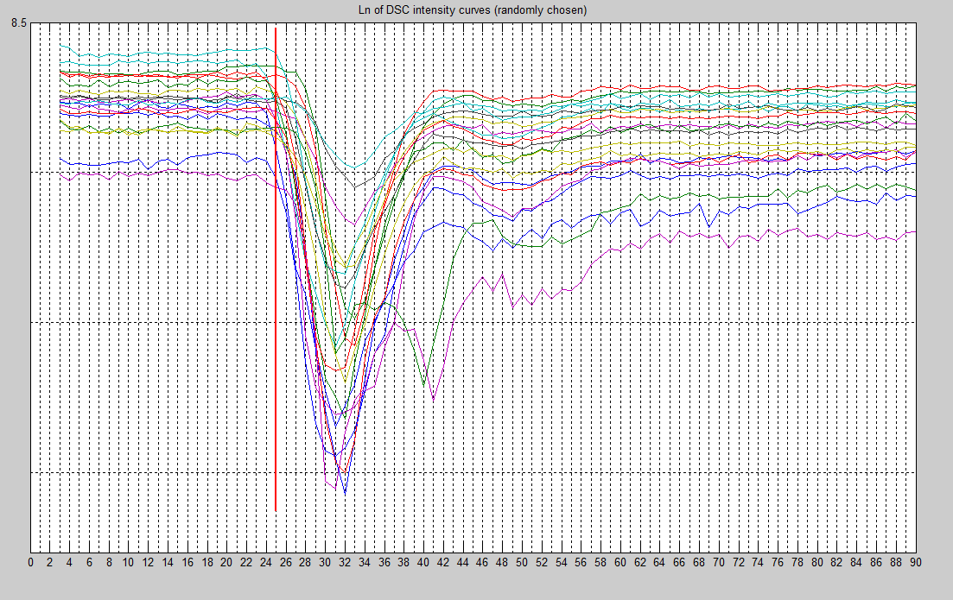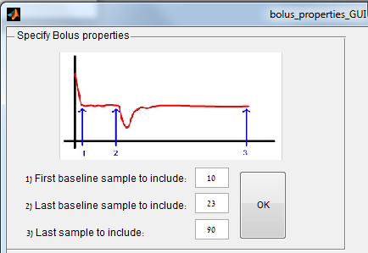

1. Choose the parameters of the bolus, and press OK.

You'll able to update the bolus properties from the DSC GUI itself, in the upper right side.

**Stage #4 – Choosing AIF**

use the sliding-bars in the right and the bottom of the data window to show brain (after mask) at specific slice and time-point. Moving the mouse over a voxel, will show its concentration curve in the window on the right:

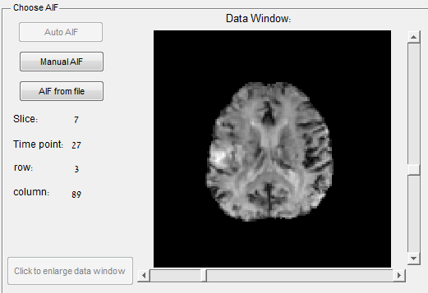 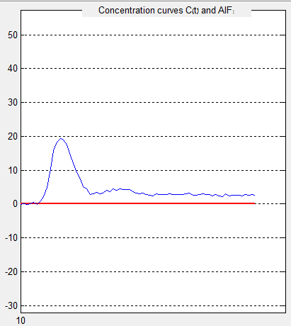

The AIF can be chosen by 3 methods

Manual AIF –

* The user chooses voxels (by pressing on them with the mouse) to participate in building the AIF.
* A chosen voxel will be marked in yellow, and its coordinates will be written in the list in the right.
* Multiple voxels (in multiple slices) can be chosen.
* The final AIF will be the average of all chosen voxels
* Deleting voxels from the list is possible.

Auto AIF –

* Not available so far.

AIF from file –

Pressing that option will open a window to choose the AIF text file.

**Stage #5 – Producing the maps**

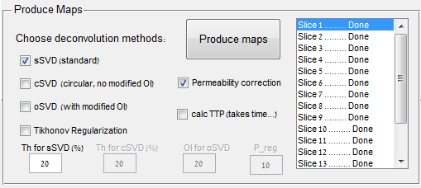

1. Choose which deconvolution methods to use (can mark more than one. each method will produce a map).
2. Mark the "permeability correction" if you want that the calculation of CBV will consider effects of permeability.
3. You can choose to calculate another parameter – TTP. (takes a lot of time).
4. Press "Produce Maps" button to start producing the maps.
5. All maps will be saved to the output folder defined in stage #1, under the folder "results\maps_<date and time>".
6. You can open the results folder by pressing "Open Maps Folder":